The purpose of this project is to create a single sign on for multiple ASP.NET applications with minimum components.

Tools and technologies:
Visual Studio 2013 community edition
Windows 7 Pro
IIS
.NET Framework 4.5

Assumptions:
The user name and the password will be hardcoded in the controller and not stored in the repository as it has to be in the real environment.
The password will not be hashed for storage in the Repository since there is no Repository
The solution will contain ASP.NET Web application SSINC that will be used by other web applications for login and authentication (only one hardcoded user name and password will be available to login to the system user name: user and password: password)
The solution also will contain a generic ASP.NET Web Application that will automatically redirect requists to the SSINC application for login and authentication any number of other ASP.NET web applications can be added to use SSINC application for centralized login

Future enhancements:
In the real world applications Web Applications after using common sign on application for autherization have to use its own implementation for authorization in other words for obtaining the Role or level of permission for the authorized user. This is something to be implemented later using Application's own repository with its User Roles data.

Setup and configuring the solution:

1. Single Sign On solution SSINC
1.1. In Visual Studio Create a New ASP.NET MVC application

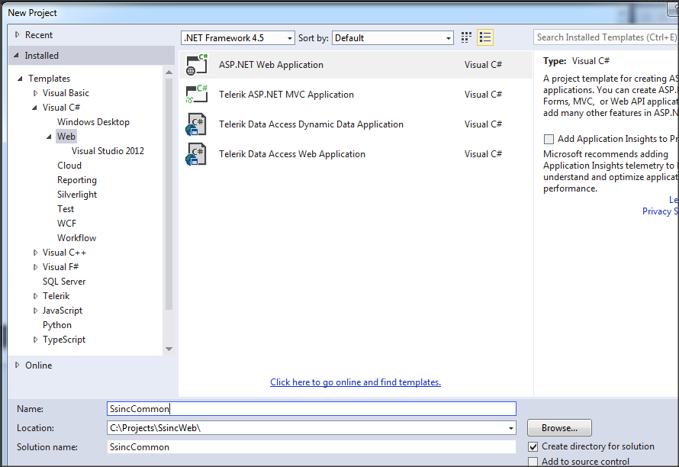

1.2. Select No Authentication
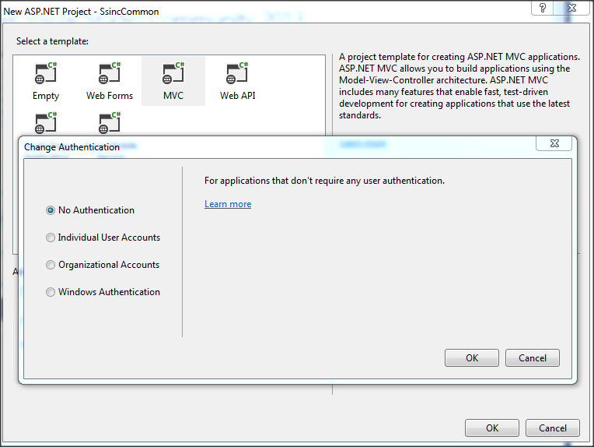

1.3. Created simple project

Solution structure:
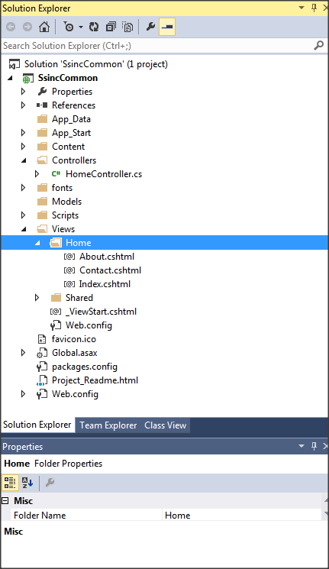

1.4. Create new Controller
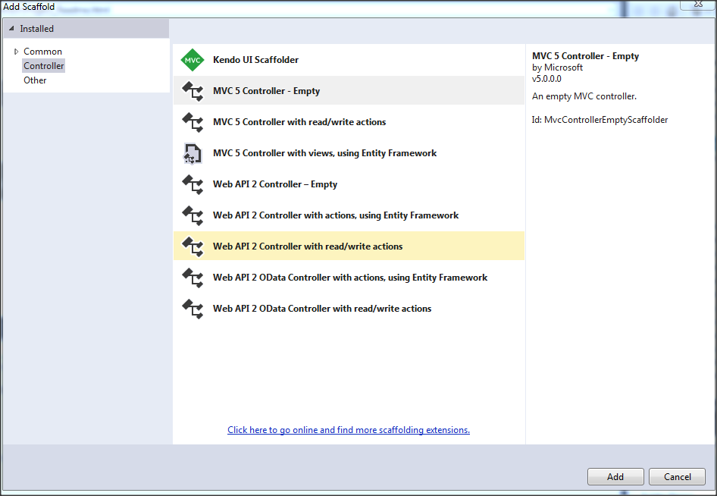

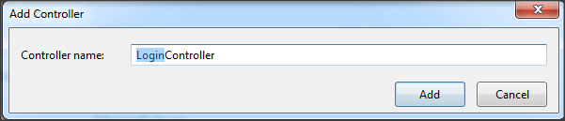

1.5. Add LoginModel to the models

1.6. Add View to controller using model LoginModel:
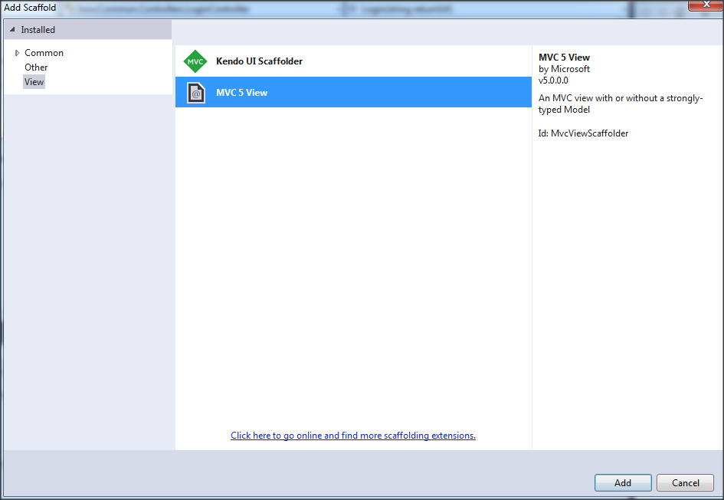

1.7. To the Web.config file add the following to the section <system.web>

<authentication mode="Forms">
<forms loginUrl="/Login/Login" timeout="2880" />
</authentication>

Add [Authorize] to the HomeController

2. Create a generic ASP.NET web application that will use SSINC application for login and authenticaton

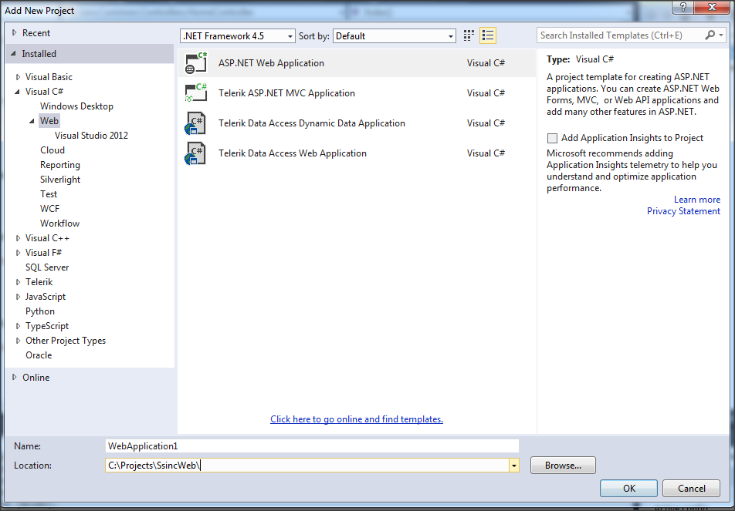

2.1. Remove option Authentication

2.2. To the Web.config file add the following to the section <system.web>

<authentication mode="Forms">
<forms loginUrl="http://localhost/SsincCommon/Login/Login" timeout="2880" />
</authentication>

2.3. Add [Authorize] to the HomeController

3. Generate Machine key for the SSINC web application:
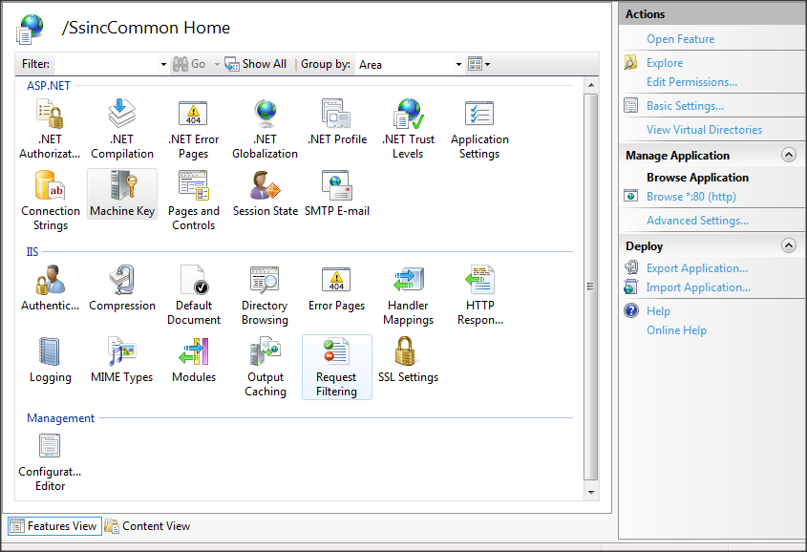

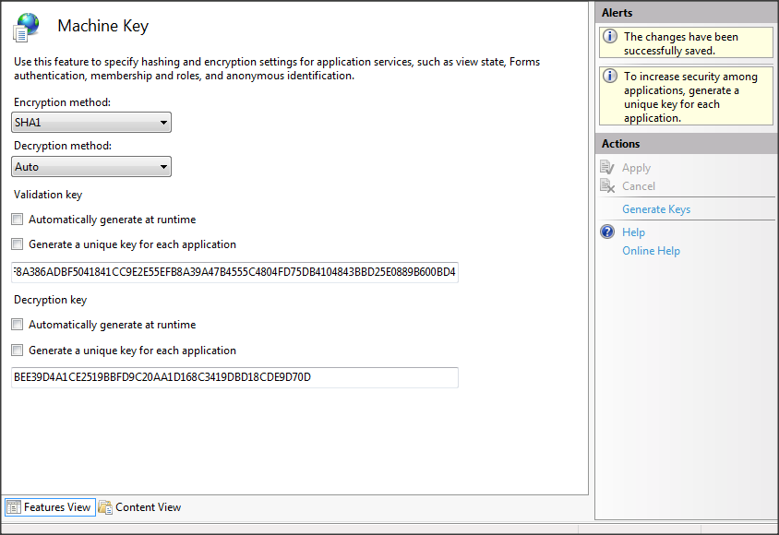
Generate Keys

find machine key in the Ssinc web.config and copy the key from the Ssinc web.config file to web.config files of the second web applications

Conclusion

The second solution utilizes SSINC web application for login and authentication.

